Software Requirements Specification

Project Tracker v1.0

Revision History:
Date | Ver. | Author | Description
07/09/2014 | 1.0 | Arun Amatya, Shankar Khatri, Shankar Koirala | Initial specification.

Introduction 4
Purpose 4
Scope 4
References 4
Assumptions and Dependencies 4
High Level Requirements 5
Detail Requirements 6
Functional Requirements 6
Nonfunctional Requirements 6
Usability 6
Reliability 6
Performance 6
Supportability 6
Security 6
Legal Requirements 7
Interfaces 8
User Interfaces 8
Hardware Interfaces 8
Software Interfaces 8
Communications Interfaces 8

Introduction

Purpose

The purpose of this document is to create a Web-based application enabling document sharing between students and faculty members helping students to complete their given assignment with proper guidance any where from the globe with the help of internet.

It will explain the purpose, features; requirements of the system intended for both stakeholders and developers of the system and will be proposed to Deerwalk Institiute of Technology for its approval.

With the help of our application various types of documents could be shared by both students and faculties.
The history of every document shared must be recorded on a dedicated server as backup to prevent big losses
describe every requirement specification of the system.

Scope
This system will be a project tracking system for Deerwalk Institute of Technology to help share documents, assignments, projects study material between students and faculty members. Addition to that, the faculty member will be able to assign any project, assignment, or term paper with a deadline to students, comment on their progresses and finally evaluate their overall performances.

References
- Business requirement documents of Project Tracker
- Historical data of projects and term papers done by students

Assumptions and Dependencies
- Students and faculty members should have a proper e-mail address of Deerwalk Institute of Technology for communication with each other as well as the system.
- Students and faculty should have a google drive account associated with the provided e-mail address.

High Level Requirements
- Students and faculty members, both should be able to share documents with each other or with some selected members.
- Faculty member should be able to assign homework, assignments, projects or term papers with a deadline to selective students.
- Faculty member should be able to view the status of the assigned work and leave comments to help student understand more.
- Faculty member should be able to grade students on the basis of work evaluation at the end of its deadline.
- Students should be able to ask help to their respective faculty members through our system.
- College admin should be able to find the status of projects, term papers. That is details about projects and term papers along with status like finished or on process etc. should be reflected from the application.

Detail Requirements

Functional Requirements
There will be three main modules in this application. They are Project, Term Paper and Student. Project module contains the all details of project such as project title, description, mentor, leader, date started etc.. Similarly, Term Paper contains the details of Term Paper such as Problem Statement, Problem Solution, Solution Type, Mentor etc.. Finally, Student modules contain all the profile details of students.

Nonfunctional Requirements
The Project tracker will be on a server with high speed Internet capability. The physical machine to be used will be determined by the Project tracker. The software developed here assumes the use of a tool such as Tomcat for connection between the Web pages and the database. The speed of the user’s connection will depend on the hardware used rather than characteristics of this system.

Usability
Project Tracker is web based application, so internet is must to access from outside of the college. Any kind of web browser with internet is enough to use this application. Since all the users are technically sound, there is no need of any kind of trainings. Just simple instruction is sufficient to use this application by targeted users. GUI is very simple and user friendly.

Reliability
This application is build by students for the college itself and the source code for this application will be available to all the current and future students so that they can add values to this application by finding bugs and adding additional useful features. So, for any kind of problem, students are available to fix it. In addition to that defect rate of the application is very low. Hence, this application is reliable to use.

Performance
Resources utilized to implement this software are one high speed server and Oracle database. So the response time is very fast with capability of handling large number of transactions at a time. System can store large numbers of records and can process it with high speed server to give quick response on each type of query available on the system.

Supportability
Since the code for this application is written in java language, large numbers of library are there to support this system for further enhancement. General convention and coding standards are used. Any new developer can quickly figure out the module and its functionality. So, support is always feasible in the application.

Security
- The database should be secured with password to prevent unwanted deletion.
- The assignments should be able to modify, delete on by the student who has created them.

Legal Requirements
All rights reserved to the developers and college admin.

Interfaces
This section defines the interfaces supported by the application. Interfaces are grouped and specified as following:

User Interfaces
Below are the screenshots of user interfaces:

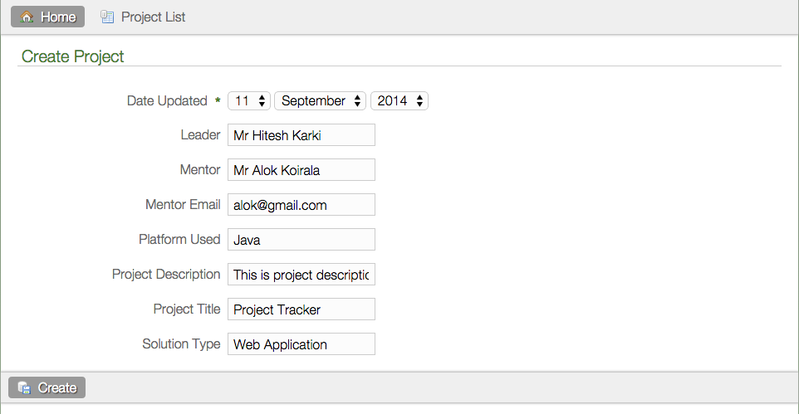

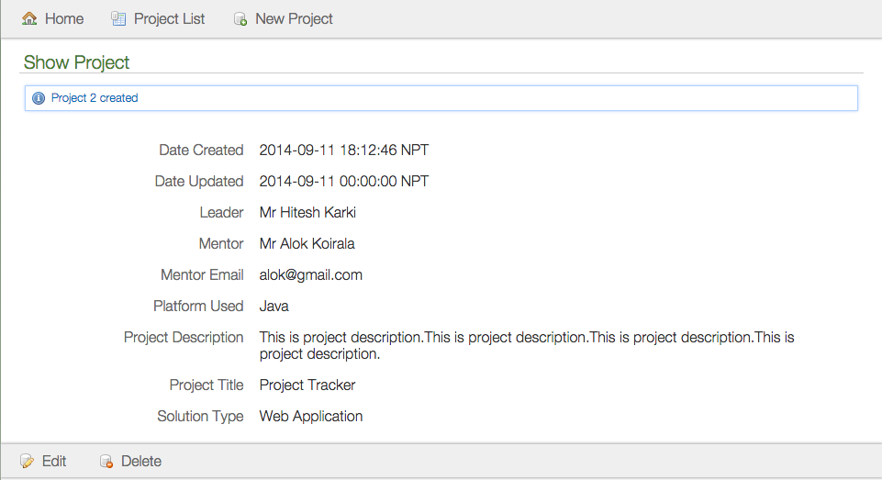
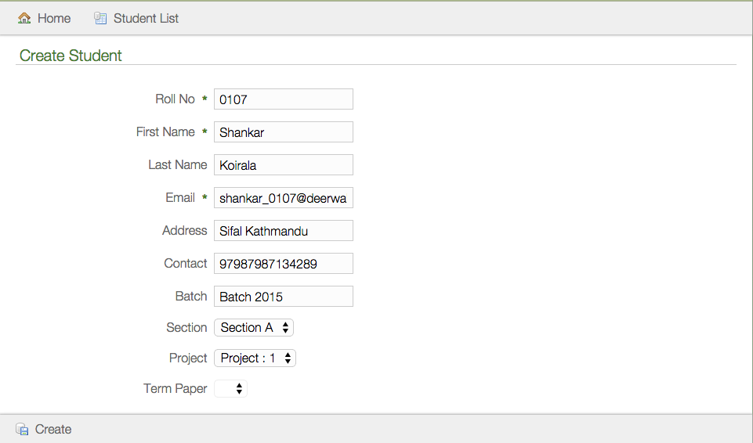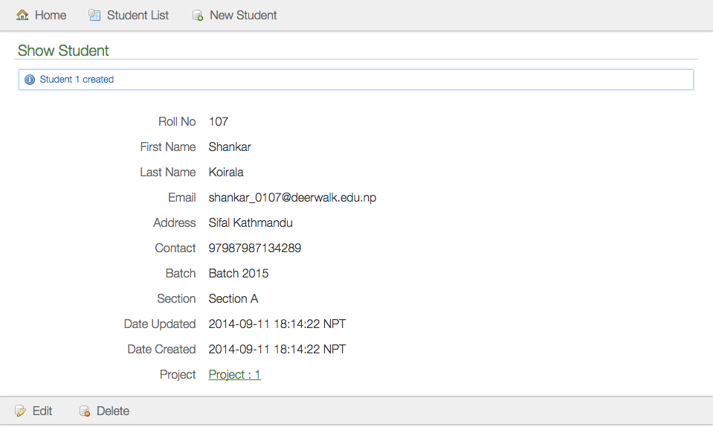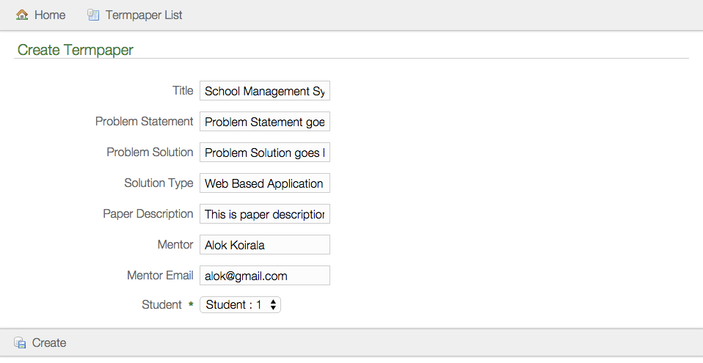

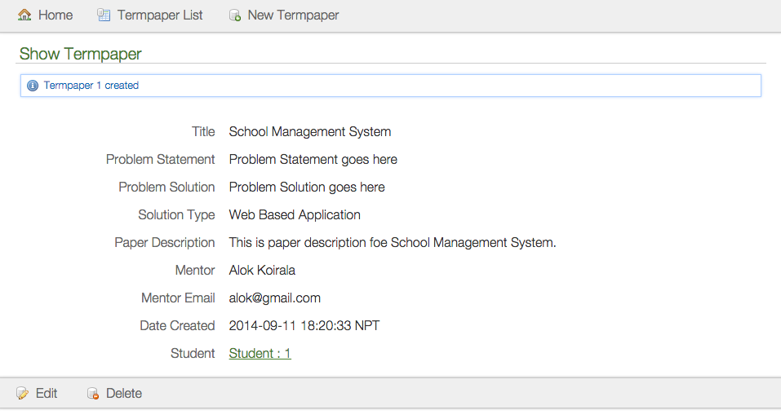

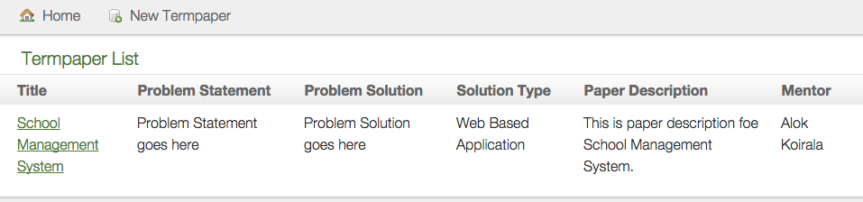

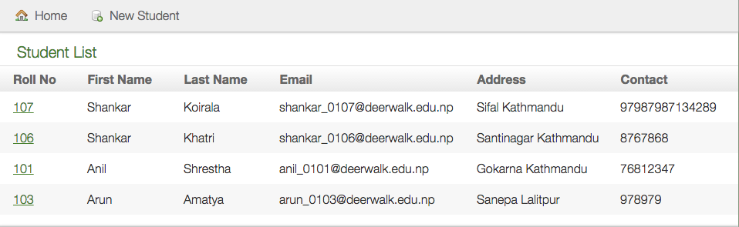

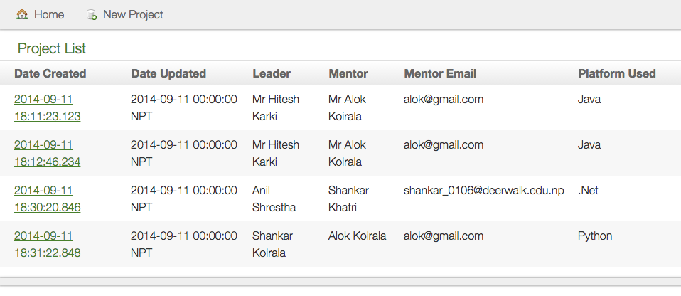

Software Interfaces
Intellij IDEA is used as an Integrated Development Environment (IDE). And Oracle database workbench.

Communications Interfaces
LAN and WAN networks along with internet is used as means of communication.

